(BAPT

Data Management and Business Intelligence

Assignment 3

Kaknou Evangelia (BAPTXXX)

Chatzimoschou Angeliki (BAPTXXX)

21 February 2016



# Step 1 Dataset selection

For this assignment the following dataset containing a list of DVD releases was chosen:

<http://www.hometheaterinfo.com/dvdlist.htm>

A MySQL database was installed locally, and the downloaded csv file was imported with the following code:

*/*Create table to extract data*/*

create table dvd_csv_extract(

DVD_Title varchar(200),

Studio varchar(200),

Released varchar(200),

Status varchar(200),

Sound varchar(200),

Versions varchar(200),

Price varchar(200),

Rating varchar(200),

Year varchar(200),

Genre varchar(200),

Aspect varchar(200),

UPC varchar(200),

DVD_ReleaseDate varchar(200),

ID varchar(200),

Timestamp varchar(200));

*/*Import data from csv*/*

LOAD DATA INFILE 'dvd_csv.txt' INTO TABLE dvd_csv_extract;

# Step 2 Data quality and staging

The following queries were executed in order to check the quality of data in each column for:

* Null values
* Uniqueness of primary keys
* Frequency distribution of values that are candidates for dimensions

*/*Check DVD_TITLE*/*

select *

from dvd_csv_extract

where DVD_TITLE is null;

*/*0 Rows: OK*/*

*/*Check Studio*/*

select *

from dvd_csv_extract

where Studio is null;

*/*0 Rows: OK*/*

select Num, count(*)

from(

select Studio, count(distinct DVD_TITLE) as Num

from dvd_csv_extract

group by Studio

order by 2 desc)x

group by Num;

*/*Many studios with just 1 movie*/*

*/*Check Released*/*

select *

from dvd_csv_extract

where Released is null;

*/*0 Rows: OK*/*

select Released, count(distinct DVD_TITLE) as Num

from dvd_csv_extract

group by Released

order by 2 desc;

*/*46191 rows with no release date*/*

*/*Check Status*/*

select *

from dvd_csv_extract

where status is null;

*/*0 Rows: OK*/*

select status, count(distinct DVD_TITLE) as Num

from dvd_csv_extract

group by status

order by 2 desc;

*/*OK*/*

*/*Check Sound*/*

select *

from dvd_csv_extract

where Sound is null;

*/*0 Rows: OK*/*

select Sound, count(distinct DVD_TITLE) as Num

from dvd_csv_extract

group by Sound

order by 2 desc;

*/*OK*/*

*/*Check Versions*/*

select *

from dvd_csv_extract

where Versions is null;

*/*0 Rows: OK*/*

select Versions, count(distinct DVD_TITLE) as Num

from dvd_csv_extract

group by Versions

order by 2 desc;

*/*OK*/*

*/*Check Price*/*

select *

from dvd_csv_extract

where Price is null;

*/*0 Rows: OK*/*

*/*Check Rating*/*

select *

from dvd_csv_extract

where Rating is null;

*/*0 Rows: OK*/*

select Rating, count(distinct DVD_TITLE) as Num

from dvd_csv_extract

group by Rating

order by 2 desc;

*/*OK*/*

*/*Check Year*/*

select *

from dvd_csv_extract

where Year is null;

*/*0 Rows: OK*/*

select Year, count(distinct DVD_TITLE) as Num

from dvd_csv_extract

group by Year

order by 2 desc;

*/*2 character values 'UNK', 'VAR'*/*

*/*Check Genre*/*

select *

from dvd_csv_extract

where Genre is null;

*/*0 Rows: OK*/*

select Genre, count(distinct DVD_TITLE) as Num

from dvd_csv_extract

group by Genre

order by 2 desc;

*/*OK*/*

*/*Check Aspect*/*

select *

from dvd_csv_extract

where Aspect is null;

*/*0 Rows: OK*/*

select Aspect, count(distinct DVD_TITLE) as Num

from dvd_csv_extract

group by Aspect

order by 2 desc;

*/*OK*/*

*/*Check DVD_ReleaseDate*/*

select *

from dvd_csv_extract

where DVD_ReleaseDate is null;

*/*0 Rows: OK*/*

select DVD_ReleaseDate, count(distinct DVD_TITLE) as Num

from dvd_csv_extract

group by DVD_ReleaseDate

order by 2 desc;

*/*46191 rows with no release date*/*

*/*Check UPC*/*

select *

from dvd_csv_extract

where UPC is null;

*/*0 Rows: OK*/*

select UPC, count(*) as Num

from dvd_csv_extract

group by UPC

having count(*)>1;

*/*This column is not unique and cannot be a primary key - column will be dropped*/*

*/*Check ID*/*

select *

from dvd_csv_extract

where ID is null;

*/*0 Rows: OK*/*

select ID, count(*) as Num

from dvd_csv_extract

group by ID

having count(*)>1;

*/*This column is unique and can be a primary key*/*

*/*Create staging table*/*

DROP TABLE IF EXISTS DVD_staging;

create table DVD_staging as

select

DVD_Title,

a.Studio,

case when b.Num <10 then 'Other' else a.Studio end as StudioGrp,

STR_TO_DATE(case when Released = '' then '1900-01-01 00:00:00' else Released end, '%Y-%m-%d %H:%i:%s') as Released,

Status,

Sound,

Versions,

cast(Price as decimal(10,2)) as Price,

Rating,

cast(case when Year in ('UNK', 'VAR') then '1900' else Year end as UNSIGNED) as Year,

Genre,

Aspect,

STR_TO_DATE(DVD_ReleaseDate, '%Y-%m-%d %H:%i:%s') as DVD_ReleaseDate,

cast(ID as unsigned) as ID

from dvd_csv_extract a

left outer join (

select Studio, count(distinct DVD_TITLE) as Num

from dvd_csv_extract

group by Studio

order by 2 desc) b

on b.Studio = a.Studio

# Step 3 Star schema design

For the star schema the dimensions selected are the following:

* status_dim describing the release status of the dvd

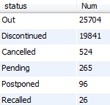

* genre_dim describing the genre of the movie

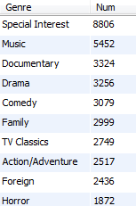

* studio_dim describing the studio that produced the movie

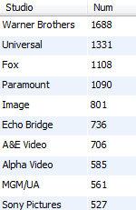

* time_dim

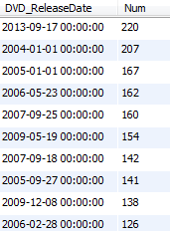

The granularity of the fact table is one row per dvd with column price as a measure.

The following diagram was generated with EER diagram of MySQL Workbench:

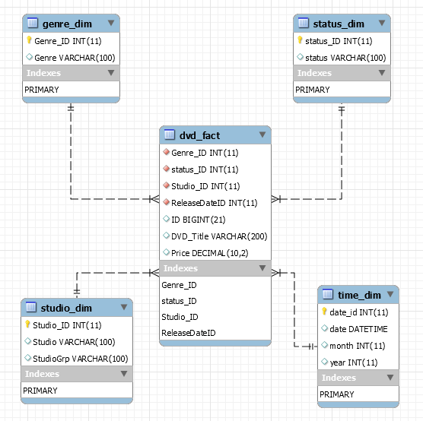

# Step 4 Schema creation and loading

The following queries were executed to create the star schema:

*/* Studio Dimension*/*

CREATE TABLE `musicdb`.`studio_dim` (

`Studio_ID` INT NOT NULL AUTO_INCREMENT,

`Studio` VARCHAR(100) NULL,

`StudioGrp` VARCHAR(100) NULL,

PRIMARY KEY (`Studio_ID`));

*/* Genre Dimension*/*

CREATE TABLE `musicdb`.`genre_dim` (

`Genre_ID` INT NOT NULL AUTO_INCREMENT,

`Genre` VARCHAR(100) NULL,

PRIMARY KEY (`Genre_ID`));

*/* Status Dimension*/*

CREATE TABLE `musicdb`.`status_dim` (

`status_ID` INT NOT NULL AUTO_INCREMENT,

`status` VARCHAR(100) NULL,

PRIMARY KEY (`status_ID`));

*/* Time Dimension*/*

CREATE TABLE `musicdb`.`time_dim` (

`date_id` INT NOT NULL AUTO_INCREMENT,

`date` datetime NULL,

`month` int NULL,

`year` int NULL,

PRIMARY KEY (`date_id`));

*/*Fact table*/*

CREATE TABLE `dvd_fact` (

`Genre_ID` int(11) NOT NULL DEFAULT '0',

`status_ID` int(11) NOT NULL DEFAULT '0',

`Studio_ID` int(11) NOT NULL DEFAULT '0',

`ReleaseDateID` int(11) NOT NULL DEFAULT '0',

`ID` bigint(21) unsigned DEFAULT NULL,

`DVD_Title` varchar(200) DEFAULT NULL,

`Price` decimal(10,2) DEFAULT NULL,

FOREIGN KEY (Genre_ID) REFERENCES genre_dim(Genre_ID),

FOREIGN KEY (status_ID) REFERENCES status_dim(status_ID),

FOREIGN KEY (Studio_ID) REFERENCES studio_dim(Studio_ID),

FOREIGN KEY (ReleaseDateID) REFERENCES time_dim(date_id)

) ENGINE=InnoDB DEFAULT CHARSET=utf8;

The following queries were executed to load the star schema:

*/* Studio Dimension*/*

insert into studio_dim (Studio,StudioGrp)

select distinct Studio,StudioGrp

from dvd_staging

where Studio not in (

select distinct Studio

from studio_dim);

*/* Genre Dimension*/*

insert into genre_dim (genre)

select distinct genre

from dvd_staging

where genre not in (

select distinct genre

from genre_dim);

*/* Status Dimension*/*

insert into status_dim (status)

select distinct status

from dvd_staging

where status not in (

select distinct status

from status_dim);

*/* Time Dimension*/*

insert into time_dim (date,month,Year)

select distinct DVD_ReleaseDate, month(DVD_ReleaseDate),year(DVD_ReleaseDate)

from dvd_staging

where DVD_ReleaseDate not in (

select distinct date

from time_dim);

*/*Fact table*/*

delete from DVD_fact where ID in (select distinct ID from dvd_staging);

insert into DVD_fact

select distinct

b.Genre_ID,

c.status_ID,

d.Studio_ID,

t.date_id as ReleaseDateID,

a.ID,

a.DVD_Title,

a.Price

from dvd_staging a

inner join genre_dim b

on b.genre = a.genre

inner join status_dim c

on c.status = a.status

inner join studio_dim d

on d.studio = a.studio

inner join time_dim t

on t.date = a.dvd_releasedate

# Step 5 Mondrian XML Schema

The following schema was created in Schema Workbench:

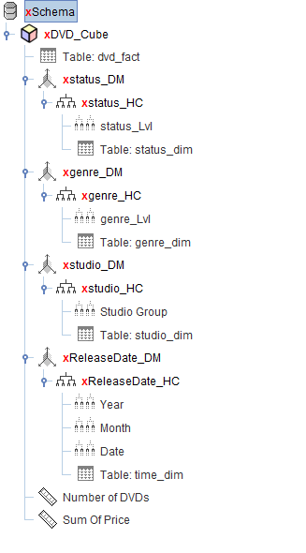

<Schema name="DVD">

<Cube name="DVD_Cube" visible="true" cache="true" enabled="true">

<Table name="dvd_fact">

</Table>

<Dimension type="StandardDimension" visible="true" foreignKey="status_ID" name="status_DM">

<Hierarchy name="status_HC" visible="true" hasAll="true" allMemberName="All status" allLevelName="All status lvl">

<Table name="status_dim" alias="">

</Table>

<Level name="status_Lvl" visible="true" table="status_dim" column="status_ID" nameColumn="status" uniqueMembers="false">

</Level>

</Hierarchy>

</Dimension>

<Dimension type="StandardDimension" visible="true" foreignKey="Genre_ID" name="genre_DM">

<Hierarchy name="genre_HC" visible="true" hasAll="true" allMemberName="All genres" allLevelName="All genres lvl">

<Table name="genre_dim" alias="">

</Table>

<Level name="genre_Lvl" visible="true" table="genre_dim" column="Genre_ID" nameColumn="Genre" uniqueMembers="false">

</Level>

</Hierarchy>

</Dimension>

<Dimension type="StandardDimension" visible="true" foreignKey="Studio_ID" name="studio_DM">

<Hierarchy name="studio_HC" visible="true" hasAll="true" allMemberName="All studios" allLevelName="All studio Lvls" primaryKey="Studio_ID" primaryKeyTable="studio_dim">

<Table name="studio_dim" alias="">

</Table>

<Level name="Studio Group" visible="true" table="studio_dim" column="Studio_ID" nameColumn="StudioGrp" uniqueMembers="false">

</Level>

</Hierarchy>

</Dimension>

<Dimension type="StandardDimension" visible="true" foreignKey="ReleaseDateID" name="ReleaseDate_DM">

<Hierarchy name="ReleaseDate_HC" visible="true" hasAll="true" allMemberName="All Dates" allLevelName="All Date Levels" primaryKey="date_id" primaryKeyTable="time_dim">

<Table name="time_dim" alias="">

</Table>

<Level name="Year" visible="true" table="time_dim" column="year" nameColumn="year" uniqueMembers="false" levelType="Regular">

</Level>

<Level name="Month" visible="true" table="time_dim" column="month" nameColumn="month" uniqueMembers="false" levelType="Regular">

</Level>

<Level name="Date" visible="true" table="time_dim" column="date" nameColumn="date" uniqueMembers="false" levelType="Regular">

</Level>

</Hierarchy>

</Dimension>

<Measure name="Number of DVDs" column="ID" aggregator="count" visible="true">

</Measure>

<Measure name="Sum Of Price" column="Price" aggregator="sum" visible="true">

</Measure>

</Cube>

</Schema>

# Step 6 Generation of reports

The following reports were generated using JPivot:

## Report1: Number of DVDs by studio and genre

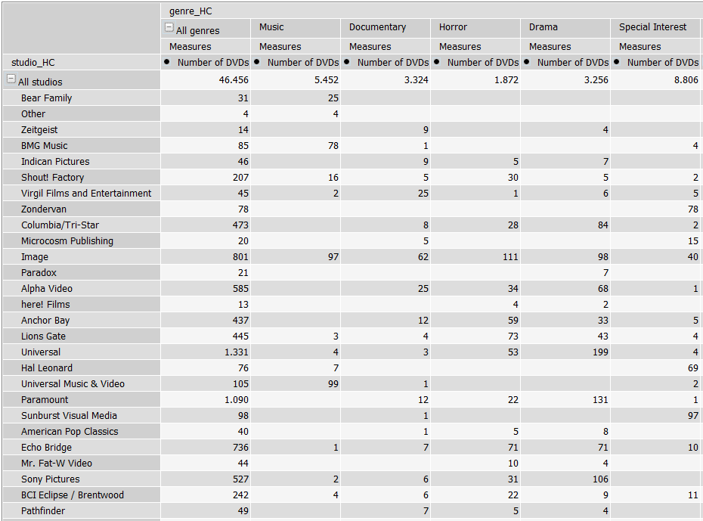

## Report 2: Number of DVDs per genre and date

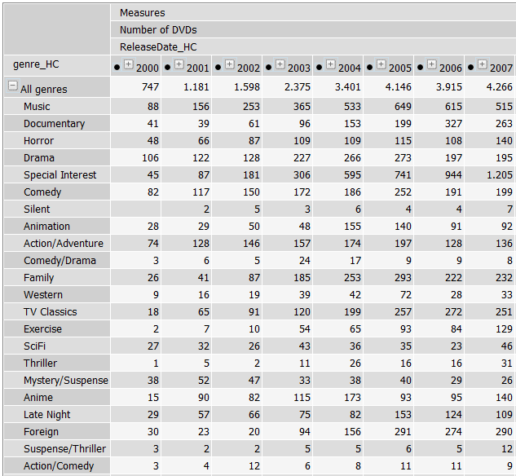

### Drill down to time hierarchy:

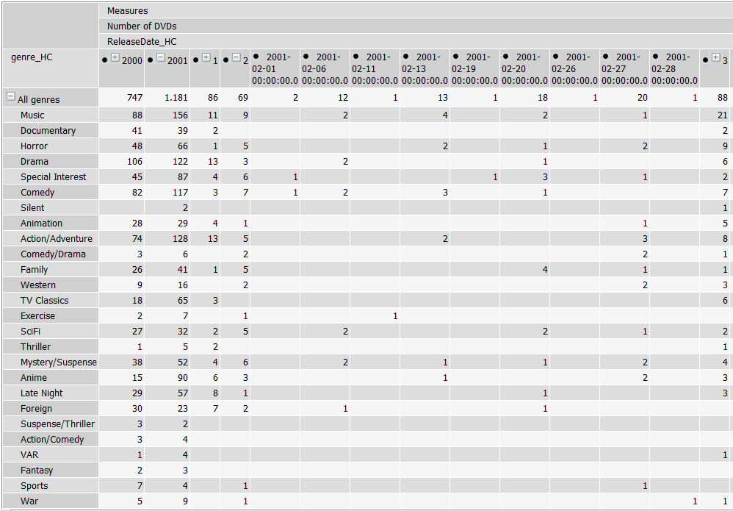

## Report 3: Sum of price per status, studio and release year

